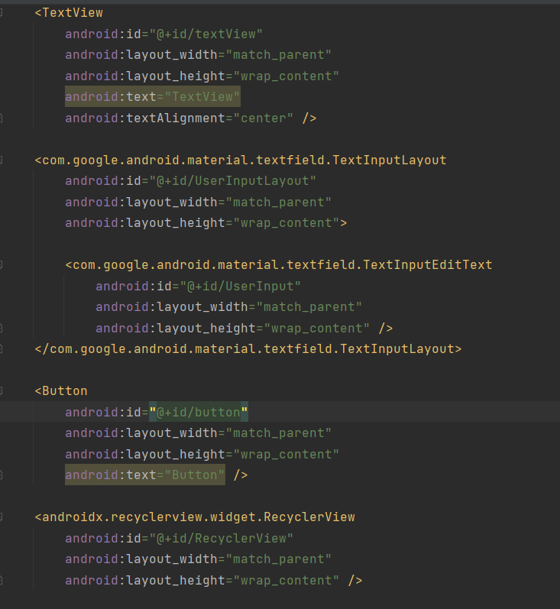

I started with making the layout for the app

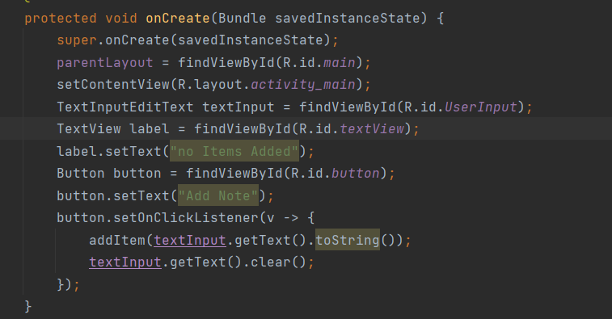

Then I set up the various variables for the backend

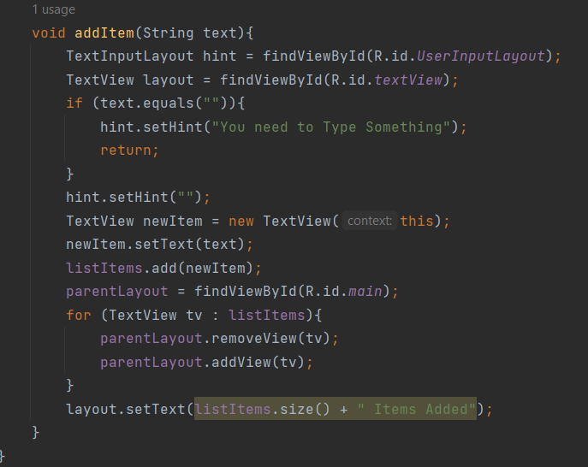

This is the code that gets used to put the items from the text input into the list that is shown on screen

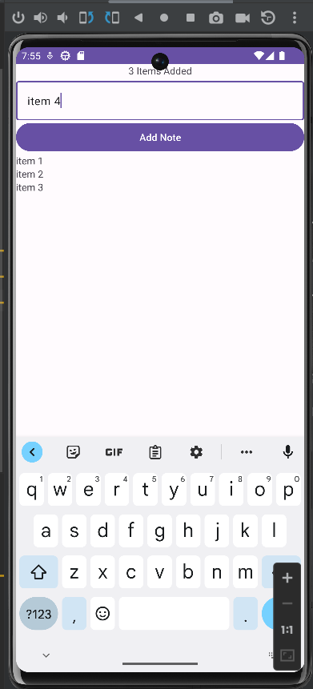

Here are the results of the program

<https://github.com/jball963/Mobile-Apps>